# Evaluation:

The project as a whole went really well yet had one major downside to it which held it back from being the best it could have been. This was the time management. This was due to the change into working from home and the motivation not being there to give me the boost I needed to complete it ASAP. Despite that, the rest of the project was completed to a professional standard which helps solidify my standard for near professional project completion. Enough of the explaining the project, lets talk about the code and how it works.

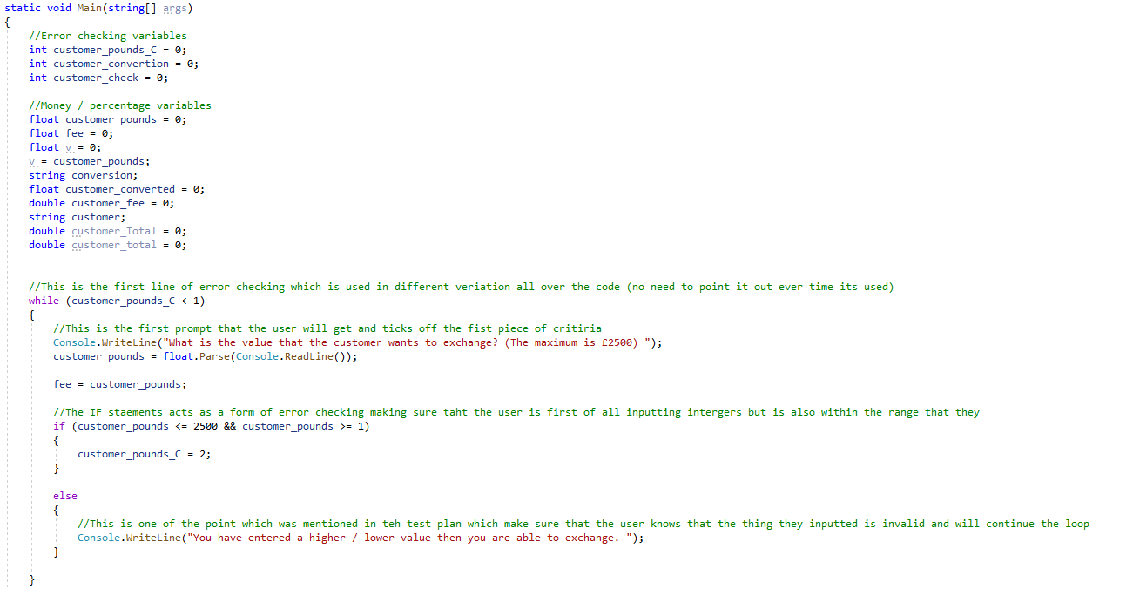

This part starts off the whole program. The variables are stated clearly at the beginning with comments describing what they’ll be used for later on in the code, which helps with debugging, while being followed up by the first statement with error checking being the first line greeting the user. Each part of the code throughout the whole programmer has a comment describing what each part is. The part above hits the first piece of criteria which is to make sure that the user (exchange agency) is able to input the amount that the user want to exchange. This is also taking into account that max is 2500 which is why I made a while loop to allow me to loop until the user inputs a float between 1 and 2500.

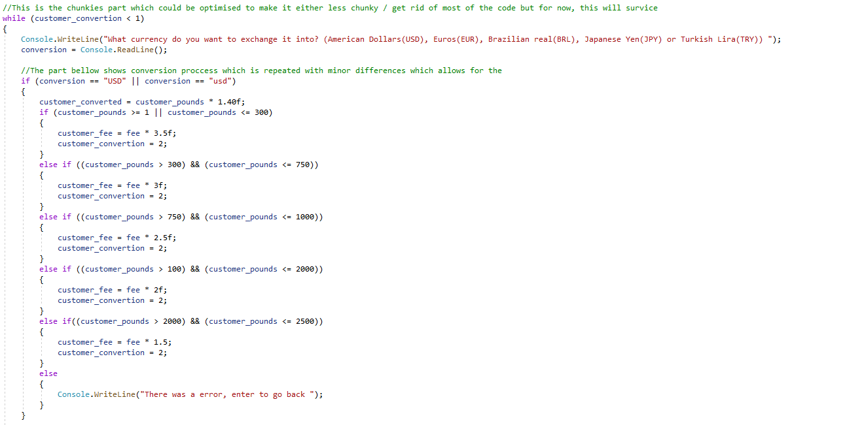

The next part shown above is a section which is repeated a fair amount throughout the code as it allows for the fee to be added and to convert the amount that the customer wants converting. The maths which is used is basic as the calculation is very basic as it’s a basic. This also ticks 2 of the criteria for being able to convert it and o add the fee depending on the amount inputted. Theres not many comment in this part as its straight forward and to the point with what its conveying.

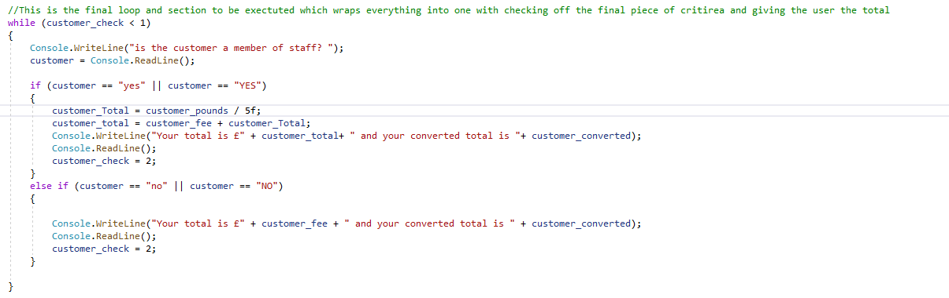

The final part hits the last piece of criteria, that being that if the customer is a member of staff, they receive a 5% discount. This isn’t the only thing within the final statement. It also calculates the total, giving the staff members the discount to the total.

In conclusion I feel like the main flaw of this project was the time management yet when it came to the level of work produced the project was good in that department. The rest of the planning and testing that went into this is also completed to the level that you would classed as professional (in my eyes at least).